

SADOP Configuration Setup

Note:- First you have to create Static IP with Port No. And share the local port with staticIP(Live IP) port to configure Sadop before starting below configuration.

1. Create Esperer Folder at the Location where Nutec infotech folder is present and copy ‘Publish_CMOnlineAPP’ in the Esperer folder.

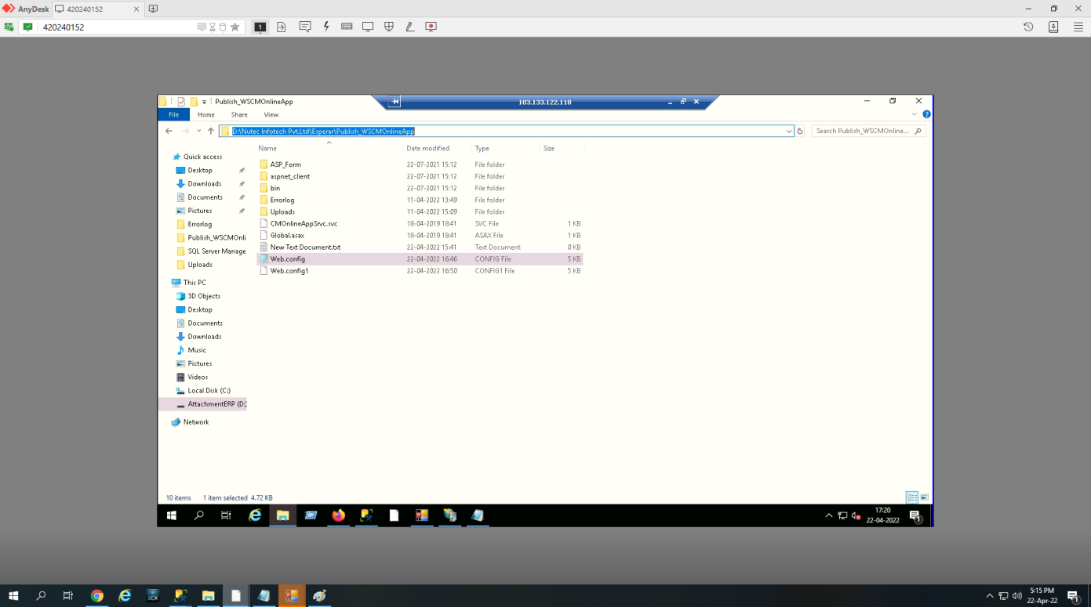

2. Open IIS Manager, Right Click on Default web site and select Add Application option and browse the location of ‘Publish_CMOnlineAPP’ folder.

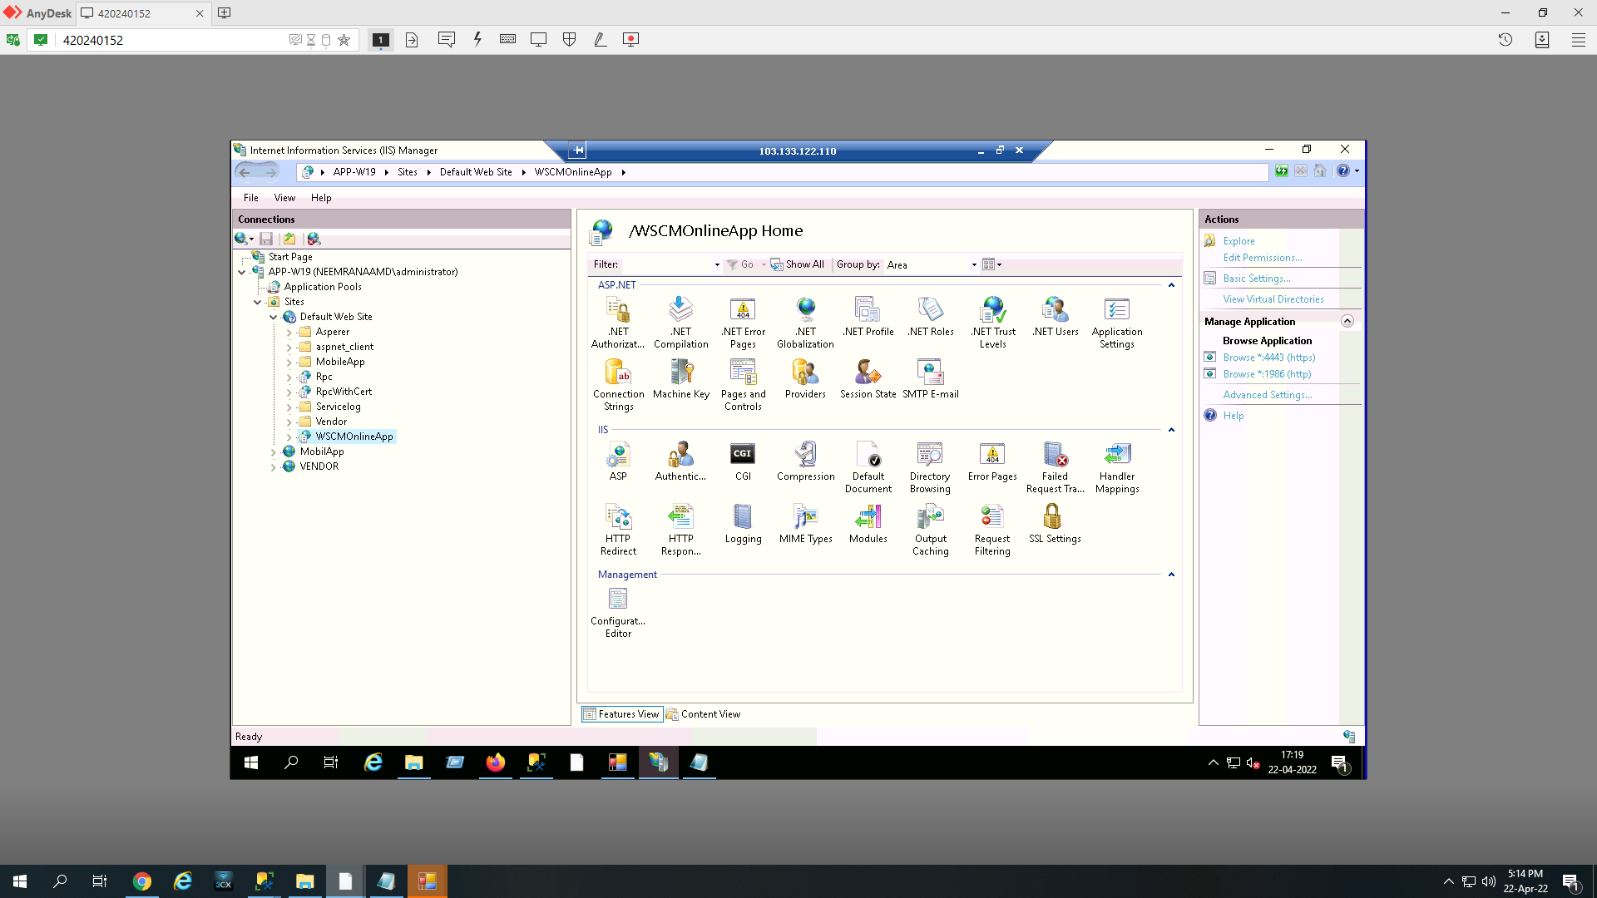

3. Go in the ‘Publish_CMOnlineAPP’ folder and edit the location of Munim Path, Munim Configuration Path , UDR Source Path , Date Source & sa Password in webconfig file.

- Change the Path of Munim Path,Munim Configuration Path, UDR Sorce Path, Databse Source Name & Password of sa user in web.config file.

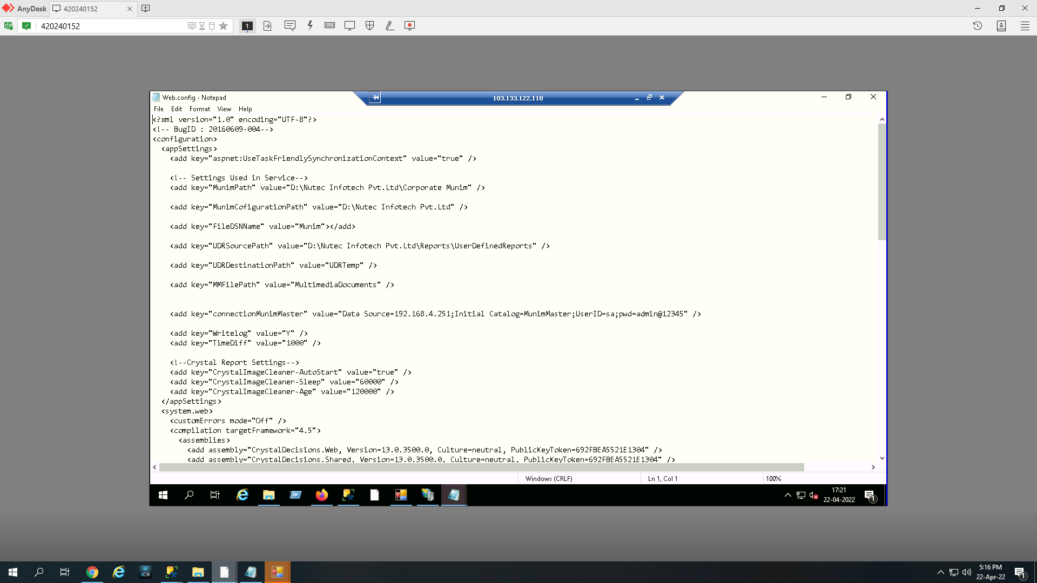

- Run the below Stored Procesdure in the Live Database.
‘CMSP_MunimMasterCurrencyNameGet’

- Run the below Stored Procesdure in the Munim Master Database.
‘CMSP_MunimMasterCompanyGroupGet’

- Run the CMOSetup.sql in the Live database.

- After successfull completion of setup , Static IP should be registered on our website at our end for respective Clients.

- After Registration, Go to the browser and enter the website http://corporatemunim.com and press enter, then system will ask for the username and you have to enter the username and press tab button then below login screen will be appeared and you can able to login from respective user you want to Login.

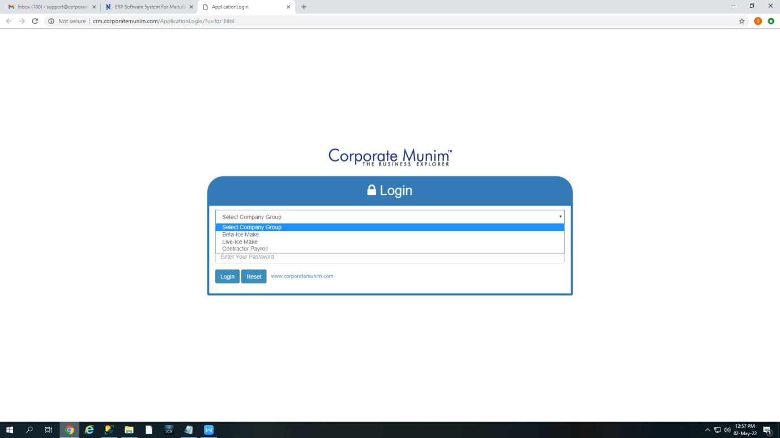

Thank You

